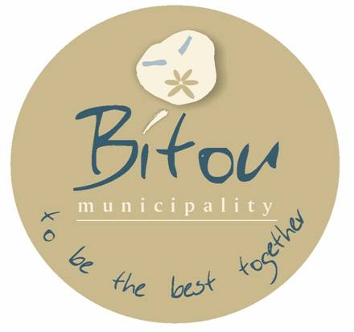

**DR. RONALD RALPH LINKS**

**ACTING MUNICIPAL MANAGER**

Bitou Local Municipality

Private Bag X1002

PLETTENBERG BAY

6600

**Municipal Notice No: 107/2024**

**BITOU MUNICIPALITY (WC047)**

**NOTICE NUMBER: NO:107/2024.**

**APPROVED DRAFT BUDGET AND TARIFFS 2024/2025 AND**

**APPROVED DRAFT INTEGRATED DEVELOPMENT PLAN (IDP): 2024/2025**

Notice is hereby given in terms of section 21 of the Local Government: Municipal System Act, 2000, Section 22 of the Local Government: Municipal Finance Management Act, 2003, and Section 127(5) of the Local Government: Municipal Finance Management Act, 2003 (Act 56 of 2003) read with Section 21A of the Local Government: Municipal Systems Act, 2000 (Act 32 of 2000) that the Draft IDP 2024/2025, Draft Budget and Tariffs 2024/2025 for the Bitou Local Municipality are available to the general public and organisations for representations and comments.

The above mentioned documents are available for inspection at the Municipal offices and libraries indicated below: Main Offices: 4 Sewell Street, PLETTENBERG BAY, Tel: 044 501 3000 (Mr. Felix Martin Lotter, Chief Financial Officer); IDP Offices: 58 Mellviles Corner, PLETTENBERG BAY, Tel: 044 501 3198 (Mr. Thembinkosi Henge, IDP Manager), Qolweni office, Green Valley office. Libraries: Town (Mellville’s Corner), Kwanokuthula, Green Valley, Kranshoek, Kurland, Central (New Horizons)

The 2024/2025 Draft IDP, Draft 2024/2025Budget and Tariffs are also available on the Bitou Municipal website: [www.bitou.gov.za](http://www.bitou.gov.za)

Comments or representations on the above mentioned documents should reach the office of the Municipal Manager on or before 18 May 2024.

To enhance public participation and to obtain meaningful input, Bitou Municipal Council decided to host IDP/ Budget consultative public meetings as scheduled below. The aim of these meetings is to provide communities an opportunity to give inputs into the draft IDP/Budget.

Purpose: Presentation Draft Budget for 2024/2025financial year.

|  |  |  |  |
| --- | --- | --- | --- |
| **WARD** | **VENUE** | **DATE** | **TIME** |
| WARD 1 | KURLAND COMMUNITY HALL | 09/04/2024 | 18:00PM |
| WARD 1 | WITTEDRIFT COMMUNITY HALL | 16/04/2024 | 18:00PM |
| WARD 2 | PIESANG HALL | 30/04/2024 | 17:30PM |
| WARD 3 | BICYCLE SHED | 11/04/2024 | 18:00PM |
| WARD 4 | NEW HORIZONS COMMUNITY HALL | 10/04/2024 | 18:00PM |
| WARD 5 | KWANOKUTHULA COMM HALL | 24/04/2024 | 18:00PM |
| WARD 6 | KWANOKUTHULA COMM HALL | 23/04/2024 | 18:00 PM |
| WARD 7 | KRANSHOEK | 17/04/2024 | 18:00PM |
| WARD 7 | HARKERVILLE | 18/04/2024 | 18:00PM |

For more information or reservations please contact the **IDP office** at 044 501 3198 or send an e-mail to [thenge@plett.gov.za](mailto:thenge@plett.gov.za) cc tnguza@plett.gov.za

**DR. DONALD RALPH LINKS**

**ACTING MUNICIPAL MANAGER**

**BITOU LOCAL MUNICIPALITY**